**Assignment 1**

**Program and Output**

Language:HTML,CSS,JavaScript

Programming and Designing:

<!DOCTYPE html>

<html>

<head>

<style>

table {

font-family: arial, sans-serif;

border-collapse: collapse;

width: 50%;

margin-left: 50px

}

tbody {

counter-reset: rowNumber;

}

table tr {

counter-increment: rowNumber;

}

table tr td:first-child::before {

content: counter(rowNumber);

min-width: 1em;

margin-right: 0.5em;

}

body {background-color:deepskyblue;}

div {

width: 400px;

padding: 10px;

border: 5px solid gray;

margin: 50px;

}

td, th {

border: 1px solid #dddddd;

text-align: center;

padding: 8px;

}

input[type=text] {

width:50%;

padding: 6px 10px;

margin: 4px 0;

box-sizing: border-box;

}

input[type=button] {

background-color: #4CAF50;

border: 2px solid #dddddd;

color: black;

padding: 16px 32px;

text-decoration: none;

margin: 4px 2px;

cursor: pointer;

}

.container {

height: 55px;

position: relative;

border: 3px solid grey;

}

.floatLeft { width:25%; float: left;

background-color: #4CAF50;

border: 2px solid #dddddd;

color: black;

padding: 16px 32px;

text-decoration: none;

margin: 10px 50px;

cursor: pointer;}

.floatRight {width: 20%; float: left;

width:20%;

padding: 6px 10px;

margin: 30px 250px ;

box-sizing: border-box;}

input[type=text]:focus {

background-color: lightblue;

}

{

background-color: #dddddd;

}

</style>

<h1 style="text-align:center">HTML Table</h1>

<table id="table" border="5">

<thead id="table-head">

<tr>

<th>Sr.No</th>

<th>First Name</th>

<th>Last Name</th>

<th>City</th>

<th>Country</th>

</tr>

</thead>

<tbody id="table-body">

<tr>

<td></td>

<td>Mayur</td>

<td>Jadhav</td>

<td>Aurangabad</td>

<td>India</td>

</tr>

<tr>

<td></td>

<td>Mayur</td>

<td>Jadhav</td>

<td>Aurangabad</td>

<td>India</td>

</tr>

<tr>

<td></td>

<td>Vinayak</td>

<td>Bharekar</td>

<td>Aurangabad</td>

<td>India</td>

</tr>

<tr>

<td></td>

<td>Ankit</td>

<td>Sharma</td>

<td>Pune</td>

<td>India</td>

</tr>

<tr>

<td></td>

<td>Mohit</td>

<td>Joshi</td>

<td>Banglore</td>

<td>India</td>

</tr>

</tbody>

</table>

<div class="floatLeft">

<form action="/action_page.php">

<label for="First Name">First Name:</label>

<input type="text" name="First Name" id="First Name" required><br><br>

<label for="Last Name">Last Name:</label>

<input type="text" name="Last Name" id="Last Name" required><br><br>

<label for="City">City: </label>

<input type="text" name="price" id="City" required><br><br>

<label for="Country">Country: </label>

<input type="text" name="item" id="Country" required><br><br>

</form>

</div>

<div class="floatRight">

<input type="button" value="Add Bottom Row" id="add" onClick="addRow()" required>

<input type="button" value="Add Top Row" onClick="insRow()" id="add1" required>

</div>

<script>

function addRow() {

"use strict";

var tableBody = document.getElementById("table-body");

var td1 = document.createElement("td");

var td2 = document.createElement("td");

var td3 = document.createElement("td");

var td4 = document.createElement("td");

var td5 = document.createElement("td");

var row = document.createElement("tr");

td2.innerHTML = document.getElementById("First Name").value;

td3.innerHTML = document.getElementById("Last Name").value;

td4.innerHTML = document.getElementById("City").value;

td5.innerHTML = document.getElementById("Country").value;

row.appendChild(td1);

row.appendChild(td2);

row.appendChild(td3);

row.appendChild(td4);

row.appendChild(td5);

tableBody.appendChild(row);

var tbody = document.createElement('table-body');

tbody.id = data.id;

}

function insRow()

{

var row=document.getElementById("table-body").insertRow(0);

var c1=row.insertCell(0);

var c2=row.insertCell(1);

var c3=row.insertCell(2);

var c4=row.insertCell(3);

var c5=row.insertCell(4);

c2.innerHTML=document.getElementById("First Name").value;

c3.innerHTML=document.getElementById("Last Name").value;;

c4.innerHTML=document.getElementById("City").value;

c5.innerHTML=document.getElementById("Country").value;

row.appendChild(c1);

row.appendChild(c2);

row.appendChild(c3);

row.appendChild(c4);

row.appendChild(c5);

}

</script>

</html>

Page:

page1=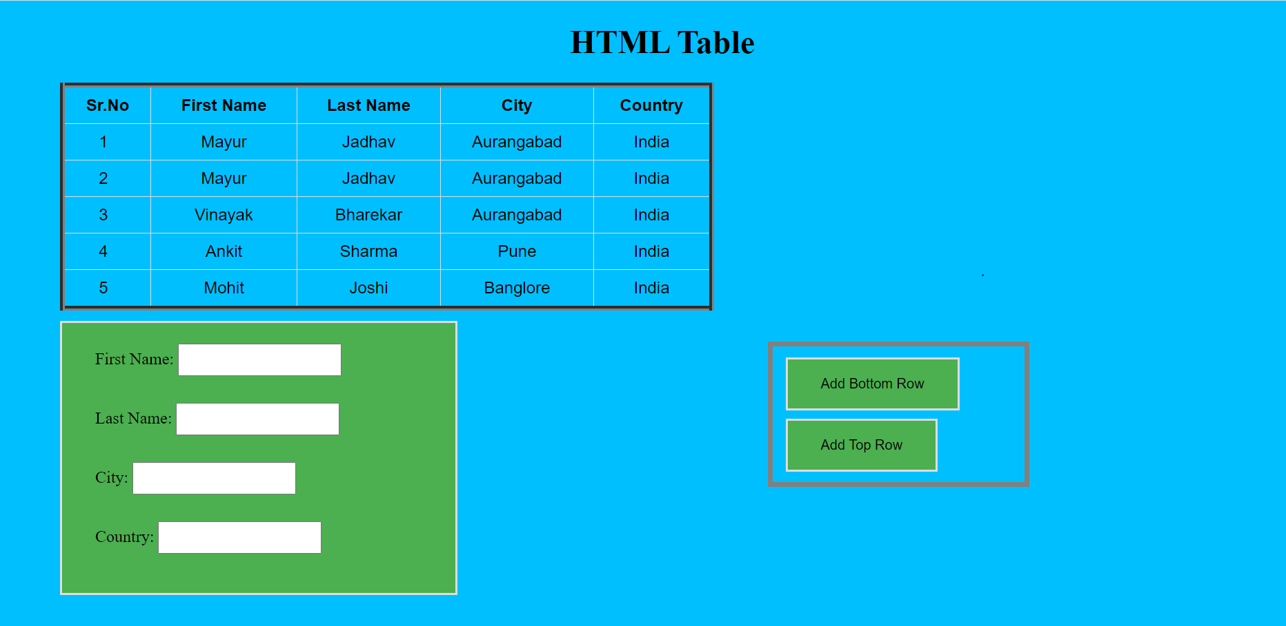

page2= After adding inputs on top as bottom with auto increment sr no index

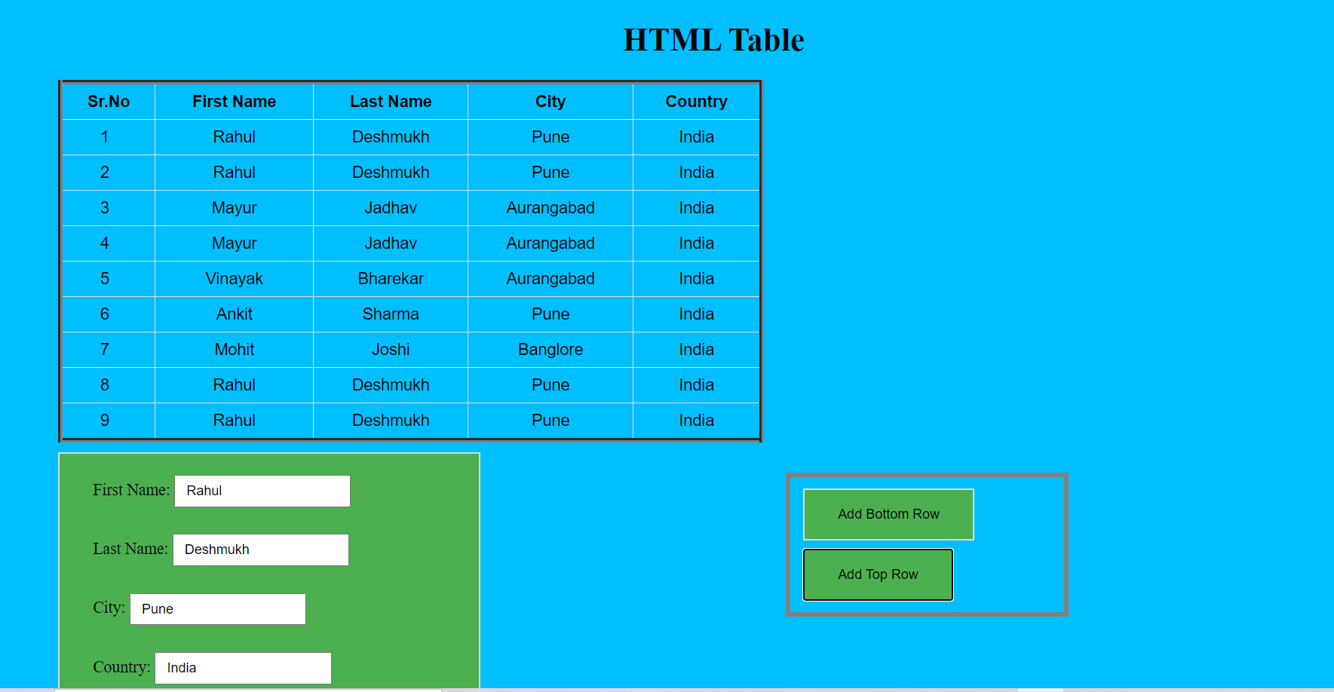

Thanks.